Solution 4

**For lead**

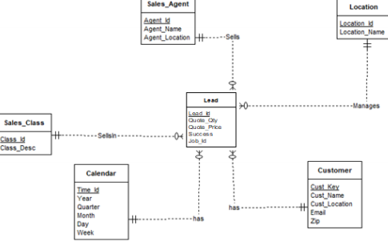

**For subjob**

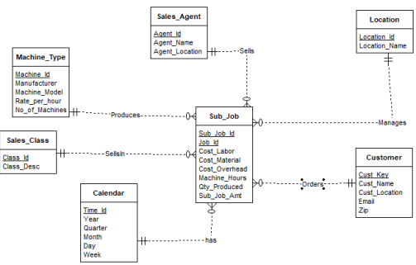

**For shipment**

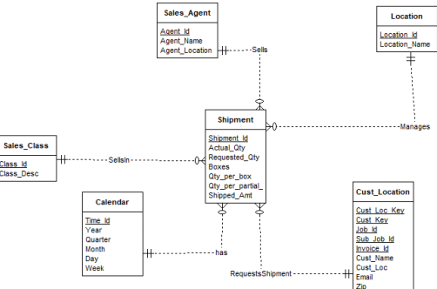

**For invoice**

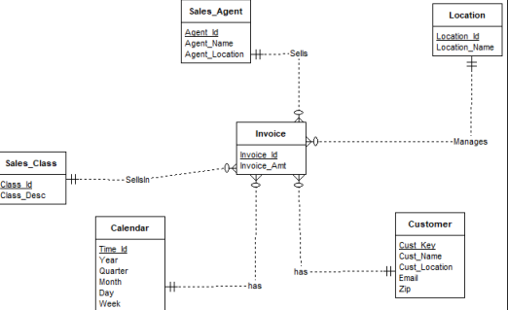

**For job**

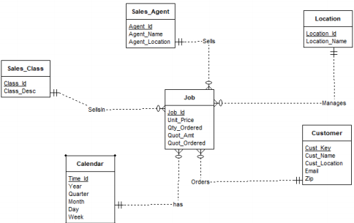

**For financialsales**

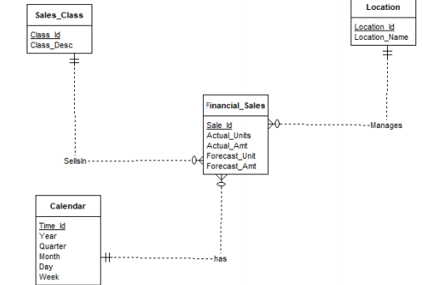

**For financial cost**

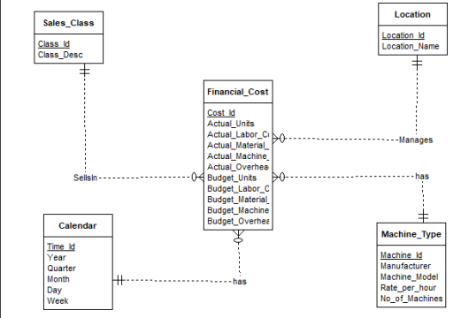

|  |  |  |  |
| --- | --- | --- | --- |
| **Schema type** | **Dimension tables** | **Fact table** | **Comments** |
| Star | Calendar, Sales Class, Sales Agent, | Lead | Job_id is included |
|  | Location, Customer |  | from the Job fact |
|  |  |  | table. Created_date is |
|  |  |  | the relation between |
|  |  |  | this fact table and |
|  |  |  | Calender. |
| Star | Calendar, Sales Class, Sales Agent, | Sub_Job | Job_Id is included as |
|  | Machine Type, Location, Customer |  | the primary key as it is |
|  |  |  | an identifying |
|  |  |  | relationship. |
|  |  |  | Date_Prod_Begin and |
|  |  |  | Date_Prod_End are |
|  |  |  | the relationships with |
|  |  |  | Calendar table. |
| Star | Calendar, Sales Class, Sales Agent, | Shipment | Calendar table |
|  | Location, Cust Location |  | relationships are |
|  |  |  | Actual_Ship_Date, |
|  |  |  | Requested_Ship_Date. |
| Star | Calendar, Sales Class, Sales Agent, | Invoice | Date_Invoiced, |
|  | Location, Customer |  | Date_Due, |
|  |  |  | Posting_Date are the |
|  |  |  | relationships with |
|  |  |  | Calendar. |
| Star | Calendar,,SalesClass,Sales agent,Loaction,customer | Job | Contract date,date promised,date ship by |
| Star | Calendar, Sales Class, Location | Financial_Sales | Begin_Date and |
|  |  |  | End_Date are the |
|  |  |  | Calendar table |
|  |  |  | relationships. |
|  |  |  |  |
|  |  |  |  |
| Star | Calendar, Sales Class, Machine Type, | Financial_Costs | Calendar table is |
|  | Location |  | related by Begin_Date |
|  |  |  | and End_Date |
|  |  |  |  |